Paul Collado
CSC-208-60
Oct 06, 2010

ColladoCh04Page197

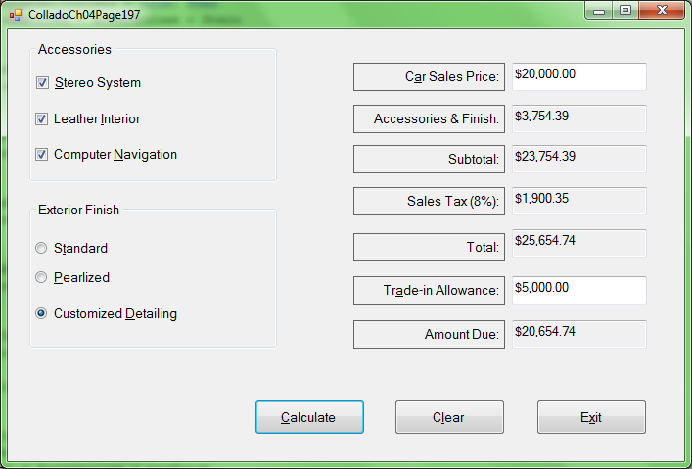

Public Class FrmColladoCh04Page197
Private Sub BtnCalculate_Click(ByVal sender As System.Object, ByVal e As System.EventArgs) Handles BtnCalculate.Click

Const Stero As Decimal = 425.76
Const Leather As Decimal = 987.41
Const Computer As Decimal = 1741.23
Const Pearlized As Decimal = 345.72
Const Detailing As Decimal = 599.99
Const TaxRate As Decimal = 0.08

Dim CarPrice As Decimal
Dim Accessories As Decimal
Dim Subtotal As Decimal
Dim SalesTax As Decimal
Dim Total As Decimal
Dim Allowance As Decimal
Dim AmountDue As Decimal

CarPrice = Val(Me.TxtCarPrice.Text)

If (ChkStereo.Checked = True) Then
Accessories = Accessories + Stero
End If

If (ChkLeather.Checked = True) Then
Accessories = Accessories + Leather
End If

If (ChkComputer.Checked = True) Then
Accessories = Accessories + Computer
End If

If (RadBtnPearlized.Checked) Then
Accessories = Accessories + Pearlized
End If

If (RadBtnDetailling.Checked) Then
Accessories = Accessories + Detailing
End If

Allowance = Val(Me.TxtTradeInAllowance.Text)

Me.TxtCarPrice.Text = FormatCurrency(CarPrice)
Me.TxtAcessoriesAndFinish.Text = FormatCurrency(Accessories)
Subtotal = Accessories + CarPrice
Me.TxtSubtotal.Text = FormatCurrency(Subtotal)
SalesTax = Subtotal * TaxRate
Me.TxtTax.Text = FormatCurrency(SalesTax)
Total = Subtotal + SalesTax
Me.TxtTotal.Text = FormatCurrency(Total)
Me.TxtTradeInAllowance.Text = FormatCurrency(Allowance)
AmountDue = Total - Allowance
Me.TxtAmountDue.Text = FormatCurrency(AmountDue)

End Sub

Private Sub BtnClear_Click(ByVal sender As System.Object, ByVal e As System.EventArgs) Handles BtnClear.Click
Me.ChkStereo.Checked = False
Me.ChkLeather.Checked = False
Me.ChkComputer.Checked = False
Me.RadBtnStandard.Checked = False
Me.RadBtnPearlized.Checked = False
Me.RadBtnDetailling.Checked = False
Me.TxtCarPrice.Clear()
Me.TxtAcessoriesAndFinish.Clear()
Me.TxtSubtotal.Clear()
Me.TxtTax.Clear()
Me.TxtTotal.Clear()
Me.TxtTradeInAllowance.Clear()
Me.TxtAmountDue.Clear()
End Sub

Private Sub BtnExit_Click(ByVal sender As System.Object, ByVal e As System.EventArgs) Handles BtnExit.Click
Me.Close()
End Sub
End Class

